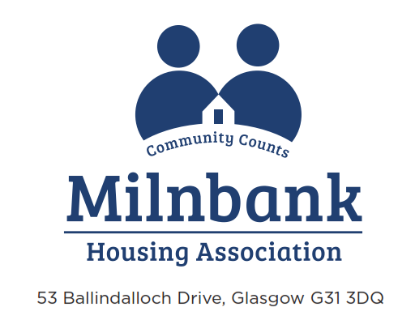

MEMBERSHIP OF THE MANAGEMENT COMMITTEE APPLICATION FORM

I have read the information pack on “Are you interested in getting involved in the Management Committee?” and now apply for membership.

Full Name:

Address:

Telephone:

E-mail Address:

Date of Birth

EDUCATION (brief details of qualifications held, if any)

EMPLOYMENT HISTORY (brief details of name of employer/positions held)

VOLUNTARY WORK (brief details of any unpaid work carried out)

POSITIONS OF PUBLIC RESPONSIBILITY HELD (eg. Community Council etc)

RELEVANT SKILLS, KNOWLEDGE AND EXPERIENCE THAT YOU WILL BRING TO THE MANAGEMENT COMMITTEE (please consider the Are you interested in getting involved in the Management Committee? Information pack

ANY OTHER RELEVANT INFORMATION

ELIGIBILITY STATEMENT

RELATED INTERESTS
Are you a MHA tenant or owner? | Yes/No
Are you related to any MHA member of staff? | Yes/No
Do you have any business or other interests which have the potential to represent a conflict of interest with the role of Management Committee member? | Yes/No
Are you a non-executive Committee member of a Public, Voluntary or Community Organisation? (please list organisation Name and your position) | Yes/No
Do you have a specific interest in a particular area of MHAs business? | Yes/No
Have you ever been the Director of a company that has gone into insolvent liquidation? | Yes/No
Have you ever been convicted of a serious criminal offence? | Yes/No
Are you declared bankrupt or are you facing bankruptcy proceedings? | Yes/No

TIME COMMITMENT

An estimate of the annual time commitment that is expected from a Management Committee member is:

ACTIVITY | TIME (per year)
Attendance at up to 10 evening meetings of the Management Committee | 25 hours
Reading and preparation for Management Committee meetings | 20 hours
Attendance at up to 4 Sub-Committee Meetings | 10 hours
Reading and preparation for Sub-Committee meetings | 8 hours
Attendance at the Annual General Meeting | 3 hours
Attendance at annual planning day and review events | 6 hours
Committee Skills Audit | 2 hours
Training, briefing sessions, committee workshops | 12 hours
Attendance at openings and site visits | Optional
Conference attendance (may include overnight stay or weekend) | Optional
TOTAL | 85 HOURS

DECLARATION

I confirm that to the best of my knowledge the information given in this application form is complete and accurate.

DATA PROTECTION

Milnbank Housing Association is registered under the General Data Protection Regulations (GDPR) and has a duty to comply with the conditions set out in this.

I give my consent to the processing of personal data, including sensitive personal data, included in this application form. The Association will process the information contained in this application form for the purposes of recruitment, selection and appointment. More information about how your data is used and the basis for processing is provided in the attached Fair Processing Notice.

SIGNED:

PRINT NAME:

DATE:

Thank you for completing this application form. Please return this to:

Milnbank Housing Association
53 Ballindalloch Drive
Glasgow
G31 3DQ
Phone: 0141 551 8131
E-mail: l.sichi@milnbank.org.uk

